Michael Weaver, No Teammate

CST – 235

Brandon Bass

11/12/2017

**Documentation for CLC – Mini Project 1**

**Question 1:** How can configuration settings of a bean be made persistent?

**Answer:** Configuration settings of a bean can be made by writing their components to an XML file. The IDE writes all the data that needs to be persisted to the file, then reads it back into the bean as needed when the program is launched on successive iterations. Alternately the bean’s setting can be stored in a database and then read into the bean as needed, similarly to the way the XML file is utilized.

**Question 2**: What is the JavaBeans API?

**Answer**: The JavaBean API is the built in methods that Java IDE use to manipulate JavaBeans. They are contained within the JavaBeans package, built directly into Java itself. The API uses methods such as EventHandler, Encoder, Introspector, PropertyChangeEvent, and XMLDecoder. All methods that are built directly into the IDE that are not normally accessed directly. JavaBeans also inherit all methods accessible to the Object class as they are in fact objects.

References

OpenJDK. 2017. The JavaBeans API. Retrieved from <http://openjdk.java.net/groups/swing/beans/index.html>

Oracle. 2017. Long Term Persistence of JavaBeans Components: XML Schema. Retrieved from <http://www.oracle.com/technetwork/java/persistence3-139471.html>

**Included Classes and Methods for Persistence**

Bean class

Private bean name field with public set and get methods

Private bean ID field with public set and get methods

Private bean number field with public set and get methods

Private bean word field with public set and get methods

FileReader class

File read method to read data from a file to restore a bean

File write method to write bean data to a file as needed

Main class

Main method to execute example as needed

**Included Classes and Methods for JavaBeans API**

Bean Class

Default no argument constructor

Event call method

Event listener response

Name bean method

Get method

Main class

Main method to execute the example

**Group Responsibilities**

Michael Weaver – All, there are no others in this group to contribute work

**Flow Diagram for Persistence**

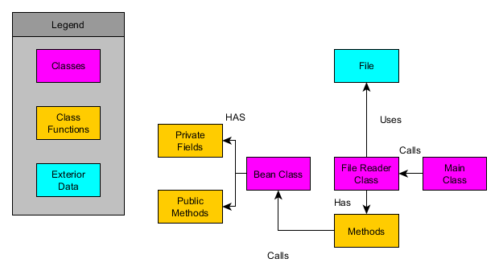

**Flow Diagram for JavaBeans API**

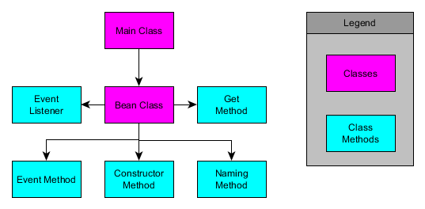

**Screenshots**

**Before Screenshot**



**Console Screenshot**

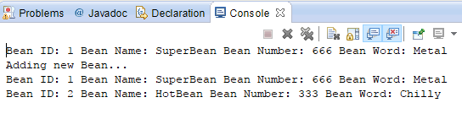

**After Screenshot**



**JavaBean API Screenshot**

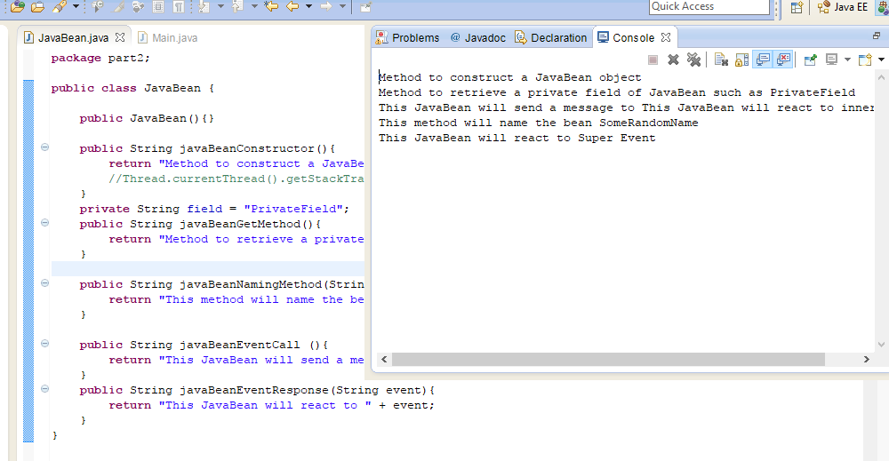

**Link to GitHub**

https://github.com/battousairurik/CST-235